**LAB NO 12**



**Fall 2024**

**CSE-304L Computer Organization and Architecture Lab**

Submitted by:

Name : **Hassan Zaib Jadoon**

Reg no**. : 22PWCSE2144**

ClassSection **: A**

Signature: ____________

Submitted to:

**Dr. Amaad Khalil**

**Department of Computer Systems Engineering**

**University of Engineering and Technology, Peshawar**

**ADDER AND ADDER SUBTRACTOR**

**TASK:1**

Write a Verilog code for Full Adder using Dataflow Level modeling.

**CODE:**

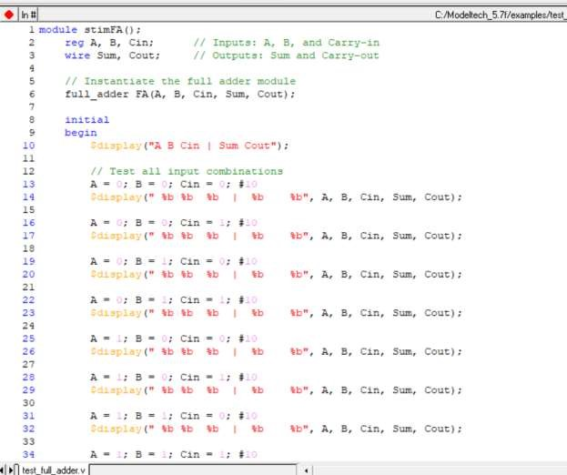

**OUTPUT:**

**Table output:**

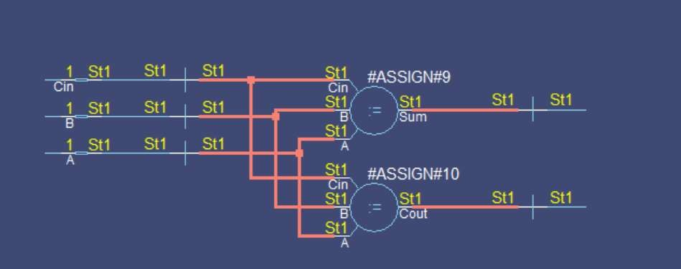

**REMARKS:**

The Verilog code for the Full Adder using Dataflow Level modeling is concise and clear, utilizing assign statements to directly express the relationships between inputs and outputs. It accurately implements the Full Adder logic by calculating the Sum as the XOR of inputs and the Cout using the OR of multiple AND operations. The code is compact, easy to understand, and correctly models the Full Adder’s behavior. However, it can be improved in terms of adding comments for further clarification, especially for beginners, and ensuring the code adheres to specific naming conventions if required by a larger project.

**TASK:2**

Write a Verilog code for Half Adder using Dataflow Level modeling.

**CODE:**

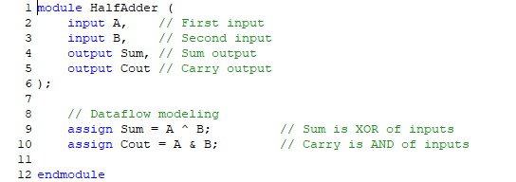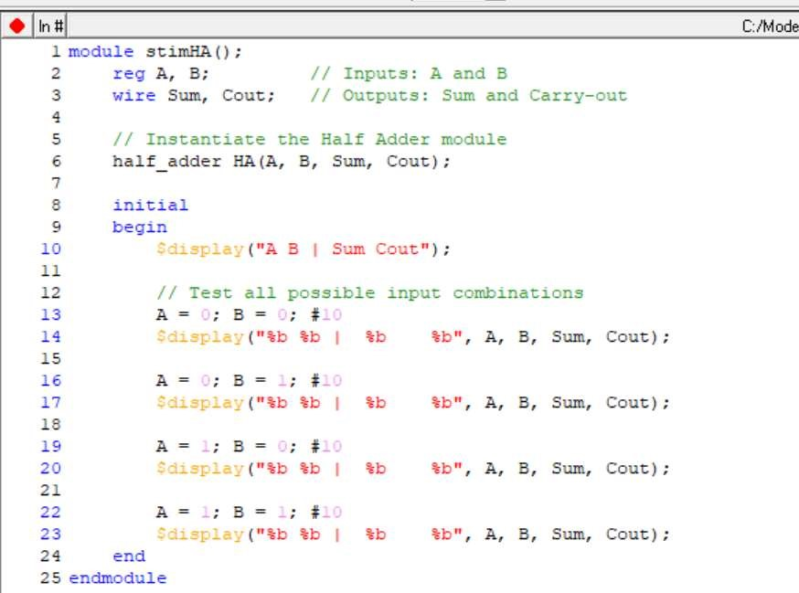

**OUTPUT:**

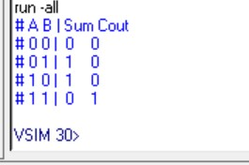

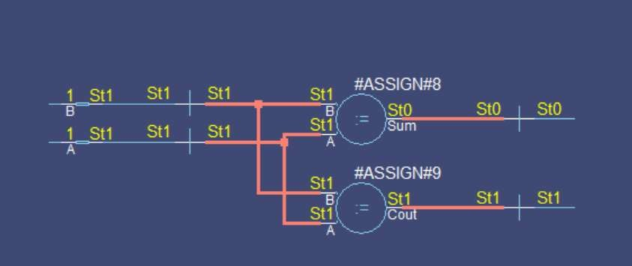

**REMARKS:**

The Verilog code for the Half Adder using Dataflow Level modeling is simple, clear, and correct. It utilizes assign statements to express the relationships between inputs and outputs, with the Sum calculated using the XOR operation (A ^ B) and the Cout using the AND operation (A & B). The code accurately models the behavior of a Half Adder, making it easy to understand and verify. However, for readability and completeness, it could include additional comments, especially for beginners, and adhere to consistent naming conventions if used in a larger design project.

**TASK 3:**

Write a Verilog code for Adder and Subtractor using Dataflow Level modeling.

**Code:**

**Output:**

**Table:**

